Name: **ZOHAIB HASSAN SOOMRO**

RollNo#: **19SW42**

Subject:



User exe mode

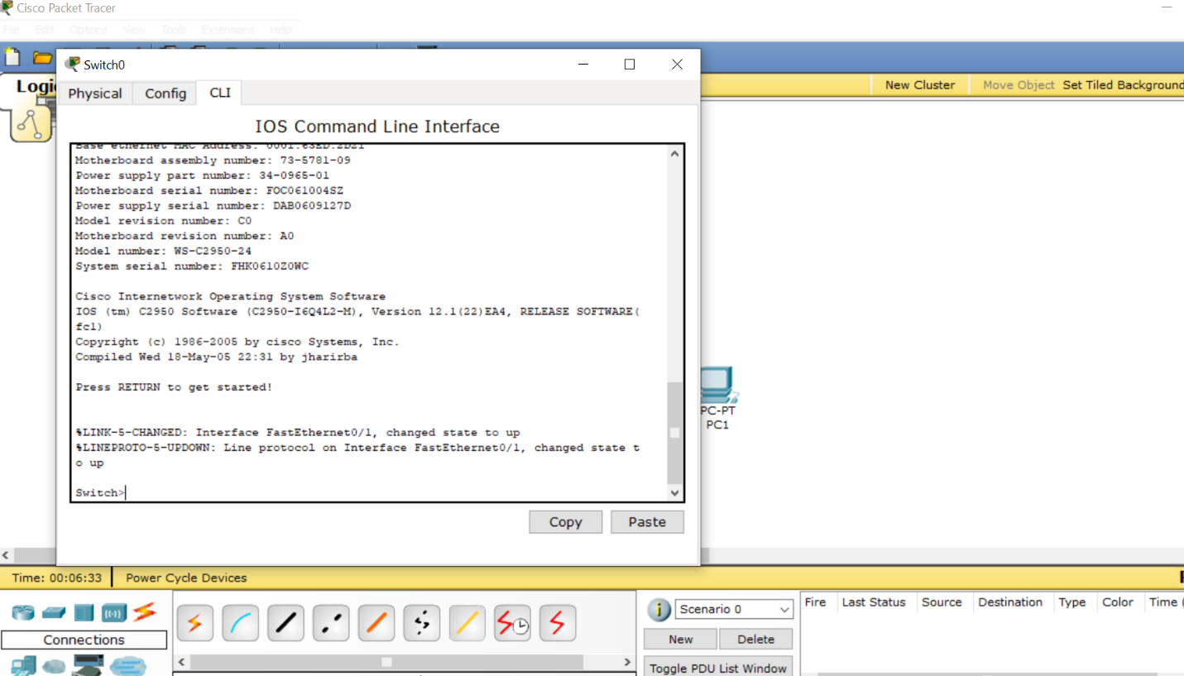

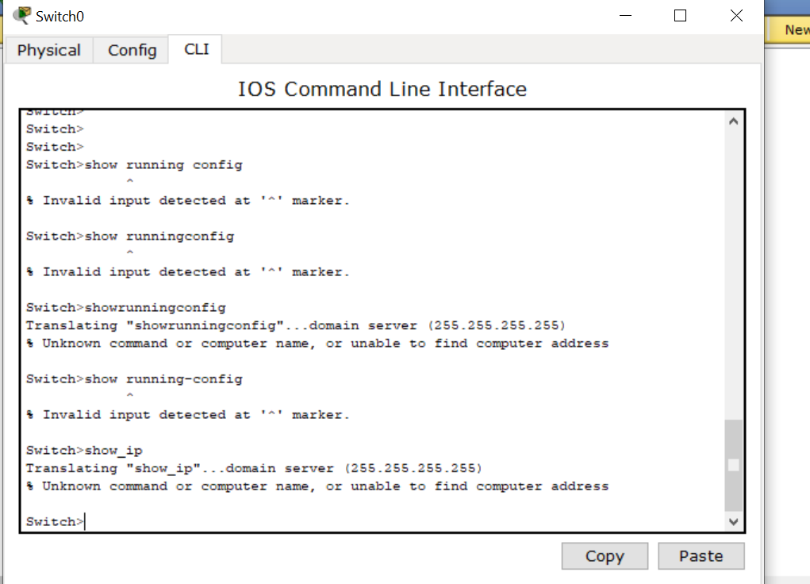

Privilege exe mode :

Type **en** or **enable**

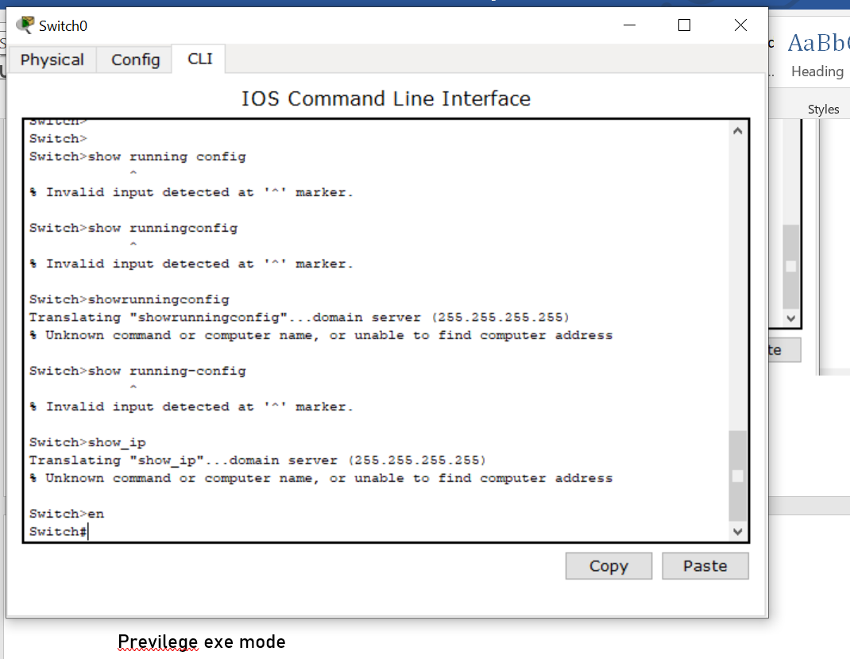

**Global Config mode:**

type **config t/configure terminal**

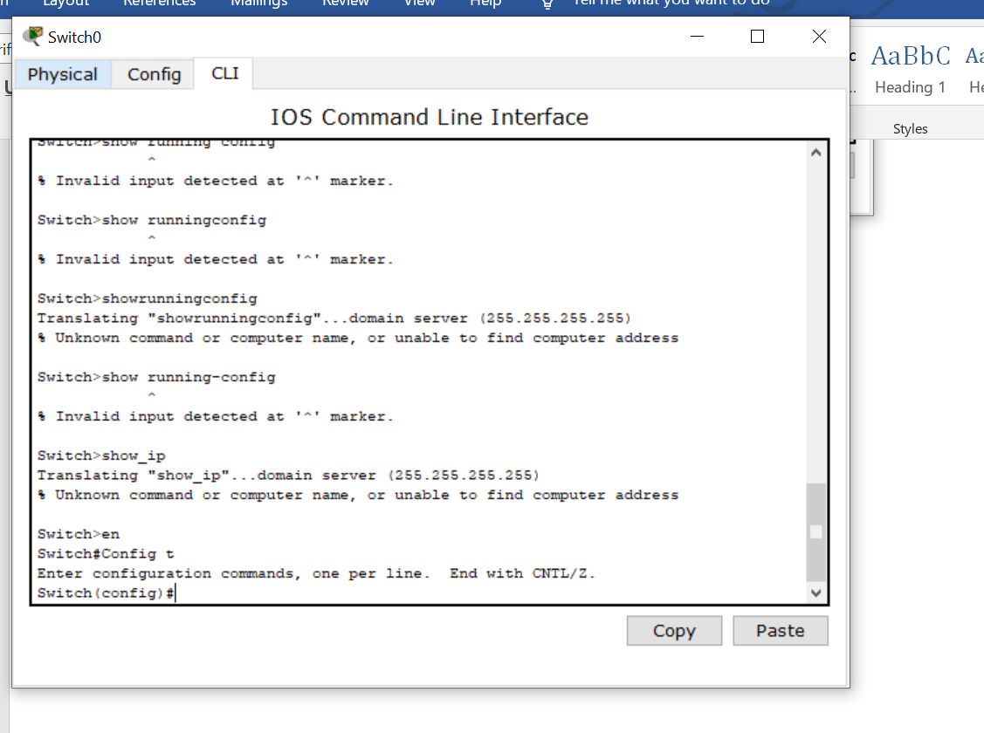

**Line Mode**:

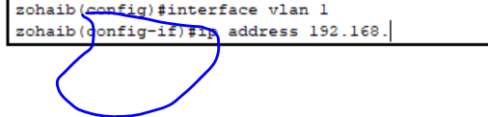

Now we can do any configurations

Going back to privilege exe mode: ctrl+Z

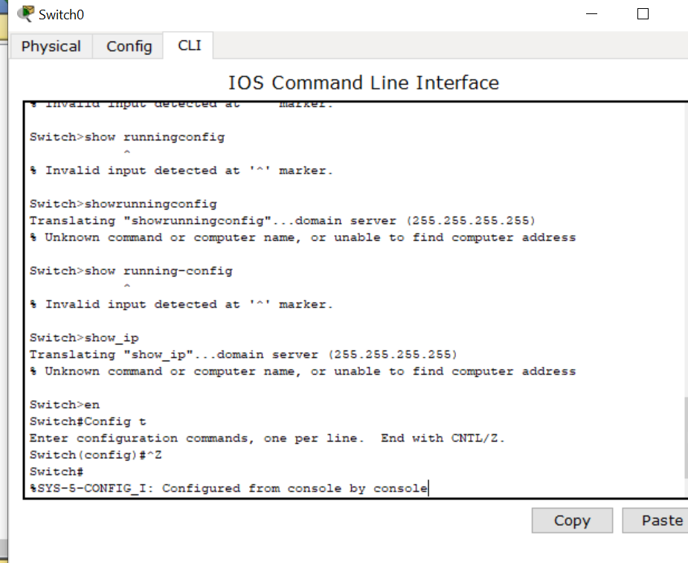

Going back to user exe mode: disable

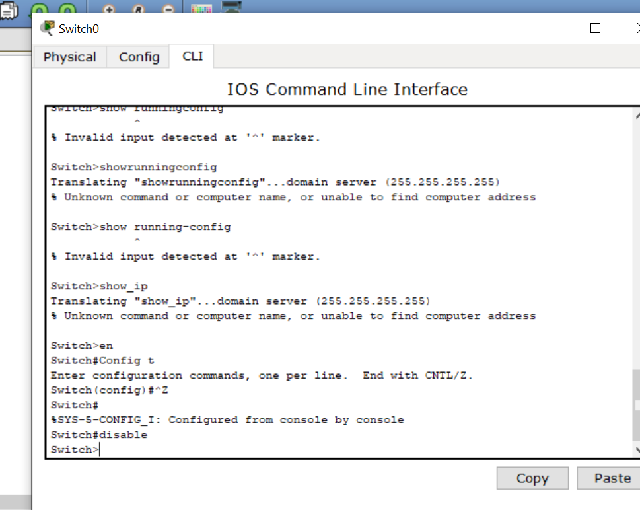

Rename a switch(being in global config mode):

Hostname switchNameHere

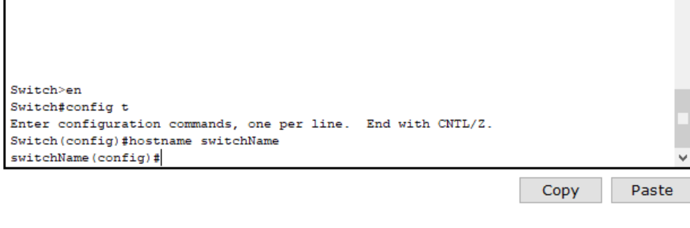

Secure a switch:

Set a password to secure a switch while user goes into privileges exe mode.

Type: **enable secret passwordHere**

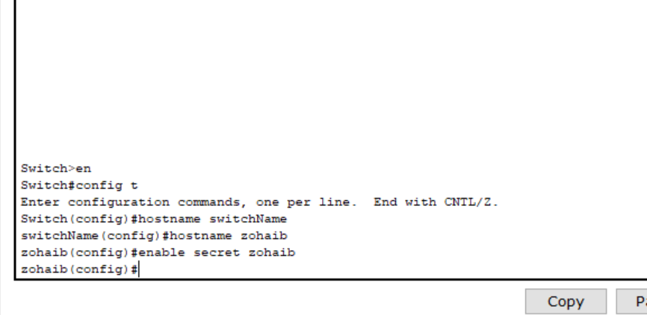

**Telnet command to access a switch by its ip.**

Set /Configure an IP for switch:

Type this:

1. Interface vlan 1
2. Ip address ipaddressHere(e.g 192.168.0.9) subNetMaskHere(255.255.255.0)

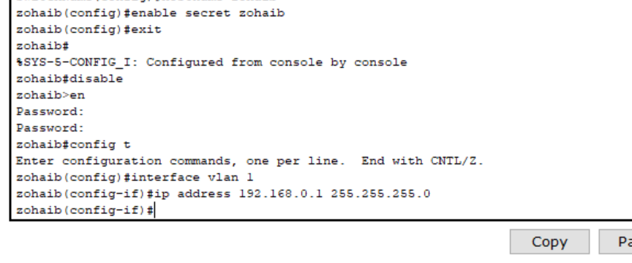

**Line mode to global config mode:**

Type **exit**

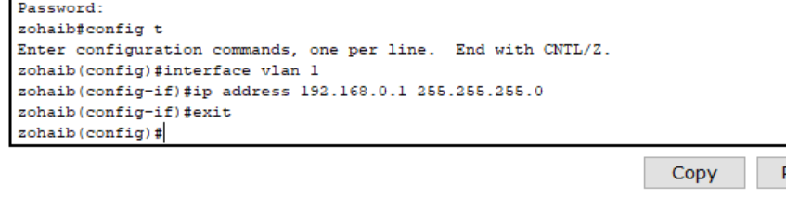

**Set gateway now:**

Type **ip default-gateway gatewayHere (e.g192.168.0.254)**

If we want to put password when someone wants to access our switch using telnet command(while in privilege exe mode).

* Every networking device has capacity to hold telnet like here we have 0 to 15

1. line vty 0 15
2. password muet
3. login

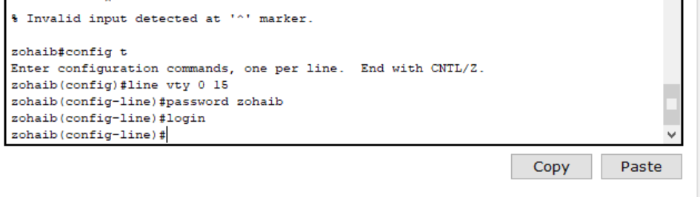

Show version command:

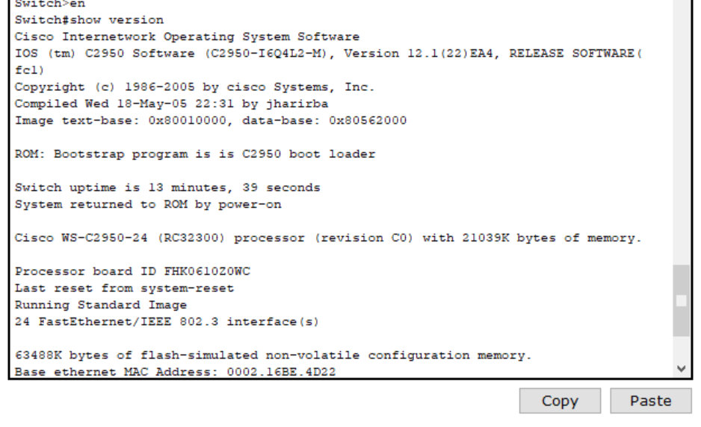

Show running-config

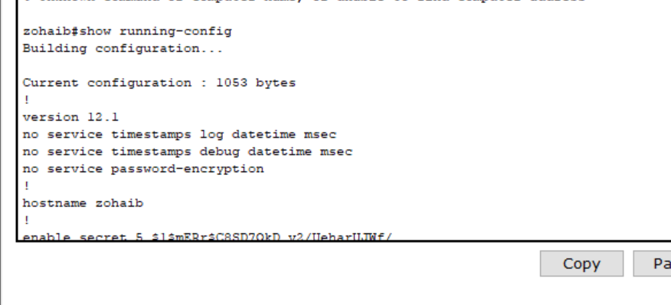

Enrypt the telnet password to increase security:

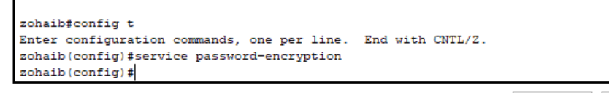

Console cable ->Rs 232 on pc side and console on switch side

